CO10029 - Fundamentals of Programming
Name: Sovithyea Prach
Student ID: 105270743
Task 2.1
Code:
#include <iostream>
#include <string>
using namespace std;

int main()
{
string name;
int mark1, mark2;
int total_mark;
float average;
string grade;

//asking for students name
cout<<"Enter name of the student: ";
cin>>name;

//asking for mark 1 and 2
cout<<"Please enter student's mark1: ";
cin>>mark1;
cout<<"Please enter student's mark2: ";
cin>>mark2;

//asking for students grade
cout<<"What is the grade? ";
cin>>grade;

//finding average
total_mark = mark1 + mark2;
average = total_mark/2.0;

//output
cout<< "The student " <<name<< " has an average score of " <<average<< " and got a " <<grade<< " grade " <<endl;
}

Output window:
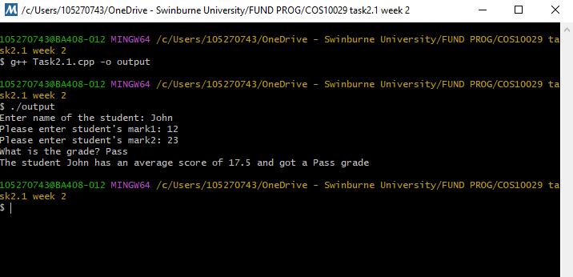

Task 2.2
Code:
#include "splashkit.h"
using namespace std;

int main()
{
open_window("Splashkit Drawing", 800, 800);
clear_screen(COLOR_BLUE);
fill_ellipse(COLOR_GREEN,0,600,800,600);
fill_rectangle(COLOR_RED, 400,400,200,200);
fill_rectangle(COLOR_YELLOW, 200,200,200,200);
refresh_screen();

delay (5000);

}

Output window:

Splashkit:
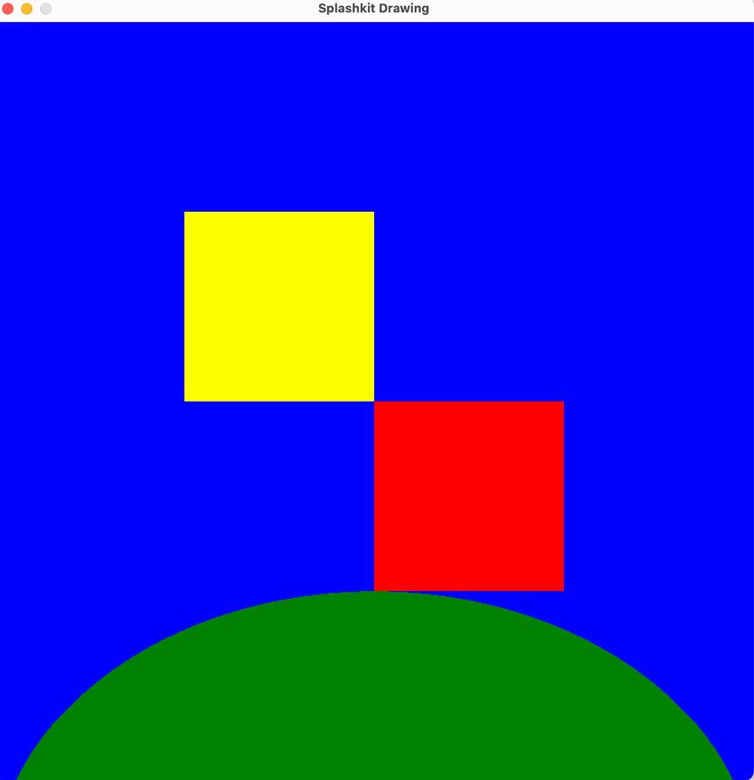

Program 1
int a, b, c;
a=10;
b=20;
c=a+b;
cout<<“ c= ”<<c<<endl;
10
a
20
b
30
c

Output: c= 30

Program 2

